Elastin-like polypeptides (ELPs) based biopolymers: production, chemoselective-functionalization and applications
Lourdes Mónica Bravo-Anaya
monik_ayanami@hotmail.com, Lourdes-Monica.Bravo-Anaya@univ-grenoble-alpes.fr

Elastin-like polypeptides (ELPs) are biopolymers composed of a pentapeptide repeat sequence Val-Pro-Gly-Xaa-Gly, where the host residue (Xaa) can be the combination of any amino acids with the exception of proline (Pro) [1]. The use of ELPs in specific biomedical and biotechnological applications has been developed mainly due to their self-assembly properties in response to different stimuli. In effect, these biopolymers undergo a reversible phase transition that can be activated by various environmental stimuli, such as ionic strength, temperature and pH. The polypeptide is soluble in water below its transition temperature (Tt), also known as the lower critical solution temperature (LCST). The phase transition can be affected by the composition of the host residue in the successive units of ELP repetition, by the salt concentration, and by the molecular weight and concentration of the ELP [2]. Currently, the field of applications of ELPs has grown in various technologies due to the possible control of their physicochemical properties and the addition of biological functions. Therefore, different ELP sequences have been conjugated with small organic molecules, drugs and oligonucleotides. We have explored, on one hand, the use of cationic ELPs for the compaction of genetic material (plasmid DNA and oligonucleotides) as an innovative genetic release system to improve the effectiveness of gene therapies. On the other hand, we have introduced different monosaccharides in the main ELP chain in order to investigate the thermo-sensitive response of the resulting glycoconjugates and their interaction with different proteins of interest (Figure 1).
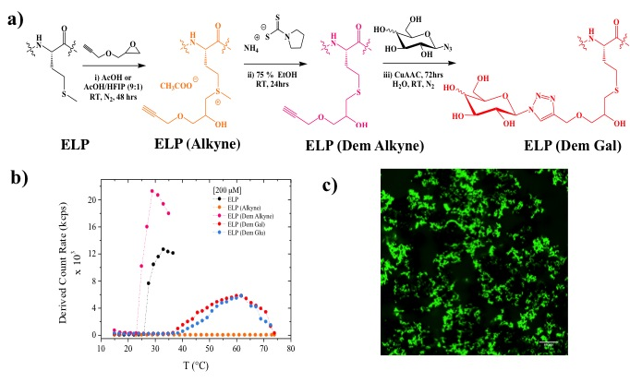
Figure 1.- a) Chemoselective modifications of ELP-M-40, b) measurements of chemically modified ELPs Tts and c) confocal microscopy image of an ELP (Dem Gal)-Lectin RCA120 aggregate.
[1] J. R. Kramer, R. Petitdemange, L. Bataille, K. Bathany, A.-L. Wirotius, B. Garbay, T. J. Deming, E. Garanger and S. Lecommandoux, ACS Macro Lett. 2015, 4, 1283−1286.
[2] D. E. Meyer and A. Chilkoti, Biomacromolecules 2004, 5, 846-851.

