Theoretical investigation of electrokinetic phenomena near ion-selective surfaces

Georgy Ganchenko
Laboratory of micro- and nanoscale electro- and hydrodynamic, Krasnodar, Russia

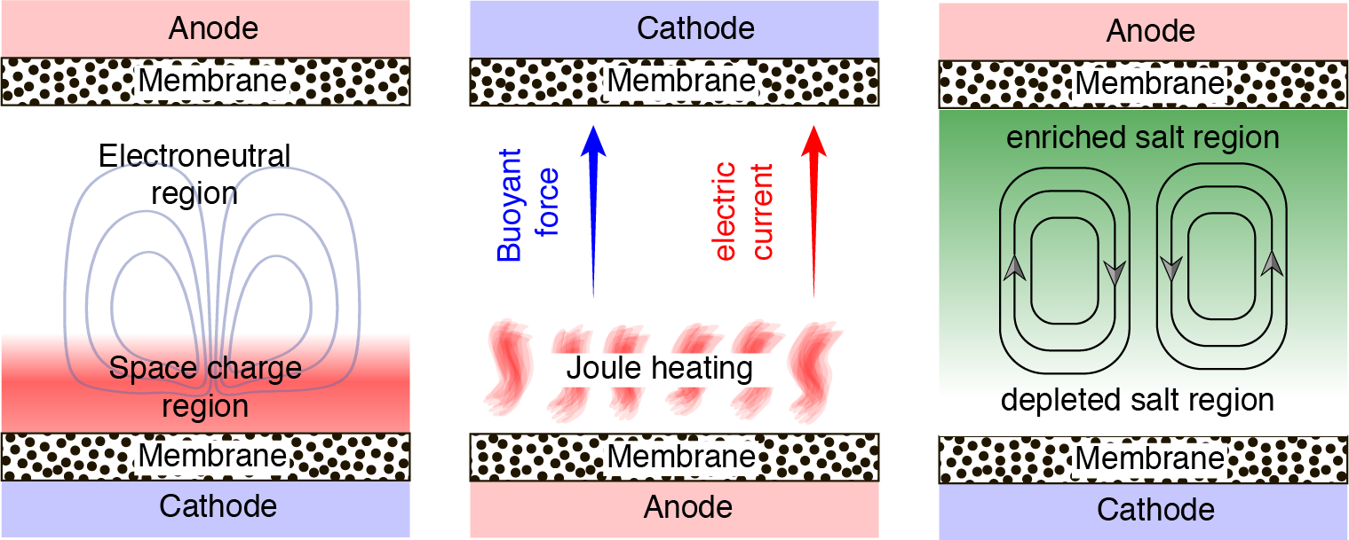
The report is dedicated to the theoretical investigation of electroconvection and transition to overlimiting current regime near ion-selective surfaces under external electric field. It is widely known that the ion-selective surfaces show amazing properties in microfluidics and many new effects can be observed in such systems. It happens due to the space charge region, which forms near ion-selective surfaces and has significantly larger length than the Debye length. It is interesting, that some new phenomena can be firstly discovered theoretically and confirmed experimentally later. We consider different geometrical statements: flat channels and spherical particles; and different additional effects, such as Joule heating and gravitational convection.
Fig. 1. Flat channel statement with additional effects.
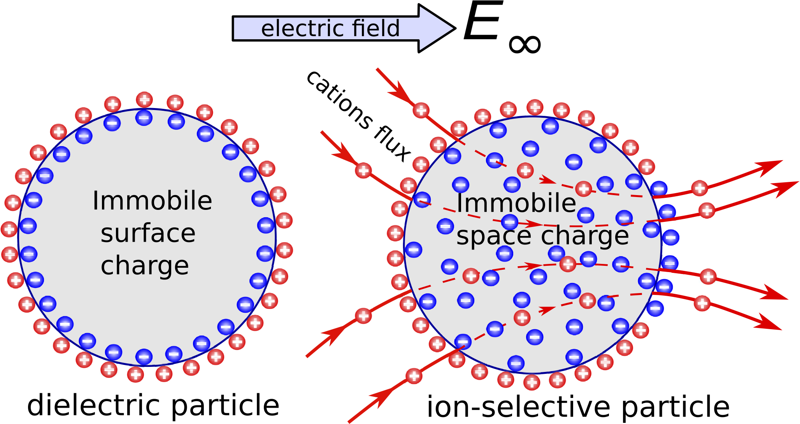
Fig. 2. Electrophoresis of an ion-selective microparticle.

