Biography of L. Zhang

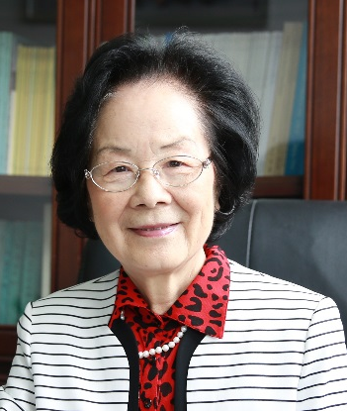
Lina Zhang (female) is an Academician of Chinese Academy of Sciences, and Professor at Wuhan University，China. She serves as an Associate Editor for ACS Sustainable Chemistry & Engineering. Her research interests include “green” conversions of natural polymers, fabrication and applications of environmentally friendly materials. Professor Zhang pioneered the development of low temperature technologies to dissolve the most intransigent macromolecules such as cellulose, chitin and polyaniline (PANI) in alkali/urea aqueous solvents with cooling that are non-toxic, low-cost and “green”. Moreover, a series of novel functional materials have been constructed directly from the cellulose, chitin, chitosan and PANI/cellulose solutions via "green" conversion methods, demonstrating their potential applications in biomedical materials, energy storage, sewage treatment and textile manufacturing etc. She has published more than 600 papers in the international journals, and her work has been cited over 20000 times. She is also one of the authors of 16 books and over 100 patents. Because of her profound research achievements and illuminating scientific discoveries, she became the first Chinese scientist received Anselm Payne Award of American Chemical Society in 2011. The “Chemistry World” of Royal Society of Chemistry made an exclusive interview for her as the vanguard of China’s green chemistry in 2016. She has been also awarded Second-place National Nature Science Prize of China (2012) etc.

Information:
College of Chemistry and Molecular Sciences, Wuhan University, Wuhan, China
Phone: +86-27-87219274(O); 15972118003.
E-mail: zhangln@whu.edu.cn

