Piling and Clogging: Colloid Accumulation under Confined Flows
Matthieu Robert de Saint Vincent
Institut de physique de Rennes, UMR 6251, 263 av. Général Leclerc, 35042 Rennes cedex
Present address: Rheonova, 1270 rue de la piscine, 38400 Saint Martin d’Hères

The flow-driven formation of colloidal materials is ubiquitous in many natural, everyday-life as well as industrial processes (to cite a few, sedimentation, drying, filtration). Yet sometimes desirable, for example to assemble colloidal crystals or deposits, colloid aggregation may also have prejudicial consequences, for instance when it leads to the clogging of filters.
In this talk, I will discuss model experiments performed to investigate at the pore scale the flow-driven accumulation of colloids in several confined environments. Flowing model suspensions through microfabricated obstacles leads to the controlled formation of aggregates. In an open geometry, a very wide diversity of aggregate shapes is obtained depending on the interplay between hydrodynamic drag and colloidal interactions (figure, left). During its growth, the aggregate influences the local hydrodynamic pattern, which in turn selects preferential growth modes depending on how cohesively the particles interact.
In contrast, within constrictions, the strong confinement greatly enhances the influence of the walls in the particle accumulation. Particles first stick onto the walls, forming monolayer-like deposits, which collect additional particles to build aggregates in the bulk. These aggregates eventually connect and clog the pore (figure, right). In this scenario, the clogging is essentially a matter of particle–wall interaction and hydrodynamic forces within the pore have little influence.

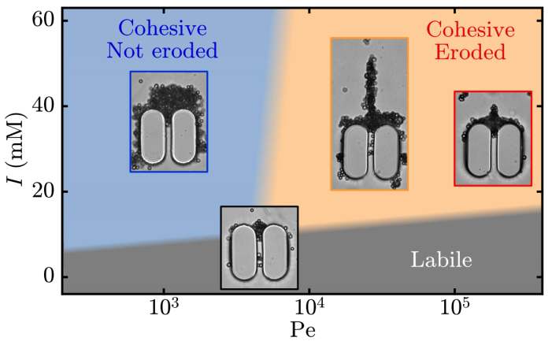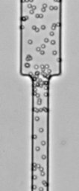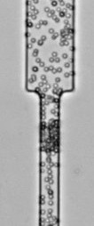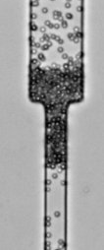
Left — Schematic phase diagram illustrating the various morphologies of colloidal structures built under flow upon a solid obstacle. Right — Progressive building-up of a clog into a constriction: first-layer deposit, aggregate growth in bulk, and pore clogging.

